**Wildman Extreme**

Tripoli L3 Certification Package

TRI 15508

by

Curtis Heisey

Feb 17, 2019

Tripoli Advisory Panel Sponsors:

W. E. (Fred) Wallace , TRA 5763

David Weber

Mike Dutch

Jim Livingston

# Overview

# My L3 rocket is a Wildman Extreme, a very tried and true 3 fins and a nose cone 4-in diameter fiberglass design. It is a dual deploy rocket, with drogue in the booster compartment, and main in the payload compartment. I added a machined thrust plate, and I glassed the fins, but these are they only mods to the kit. I used metal av bay bulkheads, which balanced the CG changed due to the glassed fins. The rocket will weight 17.7 lbs without motor or case and is 98 inches high. It will fly on a CTI 4-grain 75mm M1101. The simulated altitude is 12500 feet and Mach 1.06. My rockets tend to be “draggier” than the sim, so I doubt if it will hit Mach 1. Nonetheless, I have made design considerations for breaking the speed of sound (offset of shear pins and vent holes, strength considerations, etc.).

# The drogue will deploy at apogee by a BP charge and an e-match. It will have two redundant BP charges. There will be 3 flight computers, Raven, Quantum and Telemetrum. The Main will deploy at 700 feet via a Tinder CO2 system. It will have two BP backups.

# Highlights:

4.0 Diameter FB rocket, 98 inches in length

Booster: 58 inch long FB

Av bay: 11 inch FB coupler with 1 inch switch band

Payload: 24 inch FB

NC: 21 inch FB with Metal tip

4x ¼ inch Plywood fins, glassed, through the wall.

Weight: 17 lbs no motor or case, 29 lbs with motor

Launches on an 8ft 1515 rail

Practice flight on CTI K454m (54mm w/Aeropac adapter)

Stability : 4.26 cal

CG: 62.133 in CP: 79.457 in

Average Thrust: 102 lbs

Mass with motors: 21.l lb

Thrust to weight ratio: 4.8

Altitude: 2356

Velocity off Pad 14.6 m/s

Max Velocity 116 m/s

Max acceleration: 49 m/s^2

On CTI M1101 (75 mm

Stability: 2.82 Cal

CG: 68.016 in CP: 79.457 in

Average thrust: 250 lbs

Mass with motors 28.9 lb

Thrust to weight ratio: 8.7

Altitude 12502 ft

Velocity off Pad 21.6 m/s

Max Velocity 345 m/s

Max acceleration 99.6 m/s^2

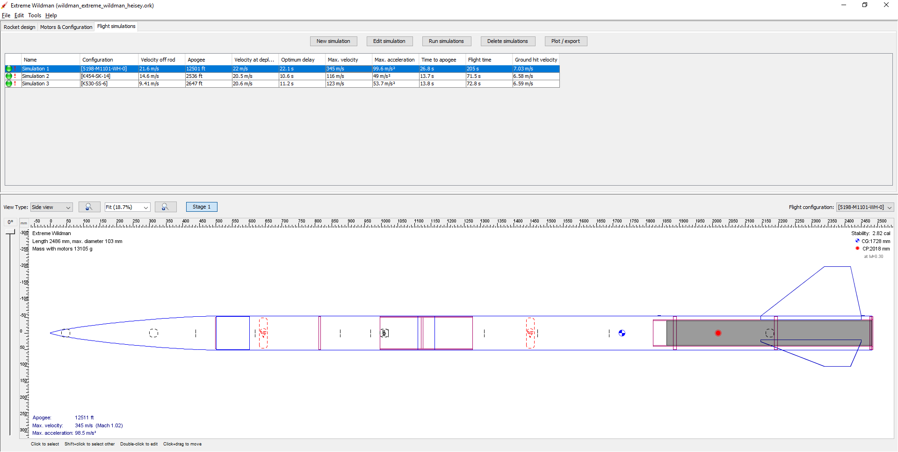OpenRocket Design and Sim

# Construction

***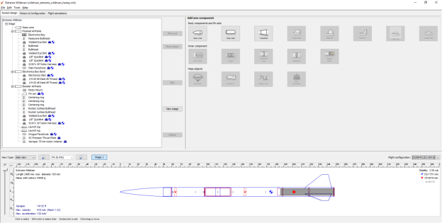***

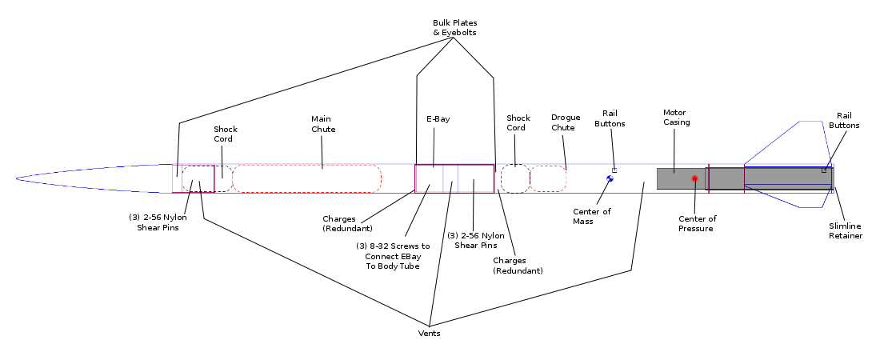

## Set of parts

**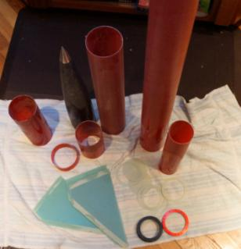**

## Bill of Materials

|  |  |  |  |
| --- | --- | --- | --- |
| **Item** | **Supplier** | **P/N** | **URL** |
| Wildman Extreme Kit | Wildman | 4 in | https://wildmanrocketry.com/collections/wildman-4-inch-kits/products/wildman-extreme |
| Thrust plate | SC Precision | 113-080-054 | http://www.scpconcepts.com/rocket-accesories.html |
| 75 mm retainer | Aeropac | RA 75 | https://aeropack.net/motorretainers.asp |
| Stainless Steel Low-Profile Binding Barrels | McMaster-Carr | 94887A142 | https://www.mcmaster.com/94887a142 |
| Super-Corrosion-Resistant 316 Stainless Steel Threaded Rods, 2 ft | McMaster-Car | 93250A440 | https://www.mcmaster.com/93250a440 |
| Av bay bulkheads | RocketJunkies | Custom | http://rocketjunkies.com/product/custom-aluminum-bulkheads/ |
| 304 Stainless Steel U-Bolt  1/4"-20 Thread Size, 7/8" ID (2) | McMaster-Car | 8889T41 | https://www.mcmaster.com/8889t41 |
| Charge Wells | RocketJunkies | 3 Gram | http://rocketjunkies.com/product/3-gram-aluminum-charge-wells/ |
| Drogue | Top Flight X form | 24 inch | https://topflightrecoveryllc.homestead.com/page1.html |
| Main | Rocketman | 8 ft Chute | https://the-rocketman.com/chutes-html/ |
| CO2 Ejection | Tinder Rocketry | Raptor | https://www.tinderrocketry.com/raptor-co2-ejection |
| Harness, Main | OneBadHawk | 25 foot, 2 loop, Nomex stitched on | http://onebadhawk.com/716-tubular-kevlar--3-loop.html |
| Harness, Drogue | OneBadHawk | 30 foot, 3 loop, Nomex stitched on | http://onebadhawk.com/716-tubular-kevlar--3-loop.html |

## Misc Parts: RocketPoxy, Stainless D-ringsWildman directions

[***https://www.dropbox.com/s/wi61fs84krcwlr5/WM%20Standard%20Dual%20Deploy%20Build%20Instructions.pdf?dl=0***](https://www.dropbox.com/s/wi61fs84krcwlr5/WM%20Standard%20Dual%20Deploy%20Build%20Instructions.pdf?dl=0)

## Wash Parts and score edges

***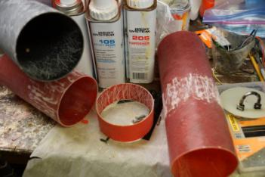***

## Glue bulkheads, NC coupler, and switch band with RocketPoxy

***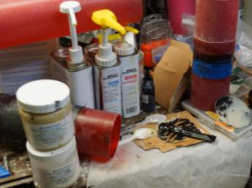***

## Glue Y-Harness

***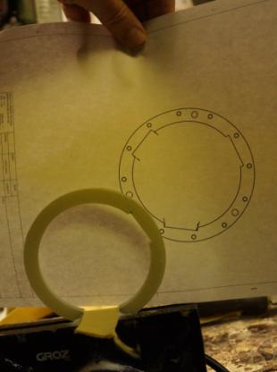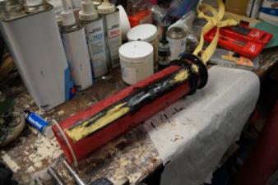***

## Insert lower rail button

***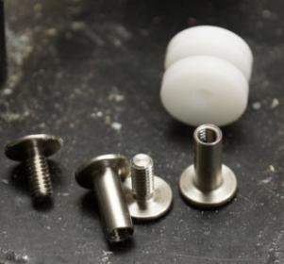***

### Stainless Steel Low-Profile Binding Barrels and Screws P/N 94887A142

### 8-32 Thread Size, for 1/2"-3/4" Material Thickness

***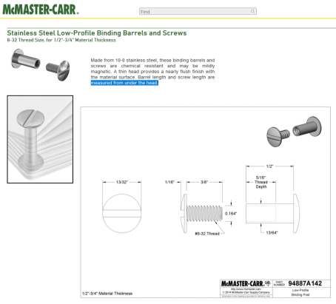***

## Glue motor mount tube in place_DSC5525.JPG

## Fin alignment:

Vertical alignment is provided by slots in body. Radial alignment is provided by 3d printed fin jig.

### Glue first fin in place using fin jig_DSC5533.JPG

### Glue fins two and three in place

***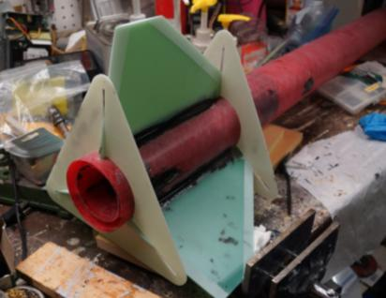***

## Strengthen NC

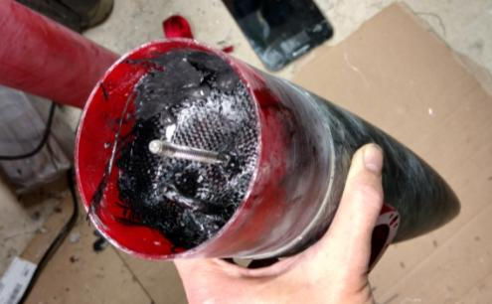

## Lower Bulkhead

The lower bulkhead is two FB centering rings. Drill holes in the bulkheads. Glue the press fits into the lower bulkhead. The bulkheads will make a sandwich to hold the press fits in place. They will hold the thrust plate on, so they must be strong. The press fits are glued, so they do not turn. This will allow bolts to be tightened.

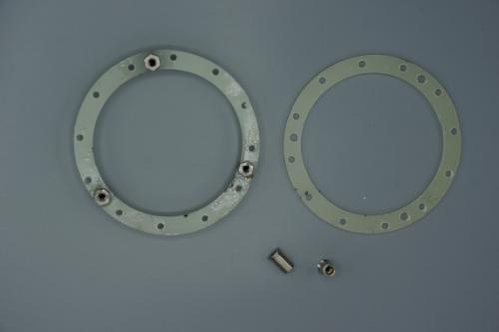

Glue internal fillets between the inside edge of the fin and the motor tube



. Make sure the thrust ring has clearance to fit. Align the holes in the pair of lower bulkheads.

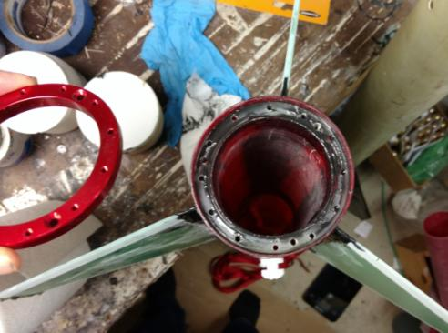

## Booster details – thrust plate

SC Precision thrust plate

Aeropac retainer for motor retention. FB tube for motor mount.

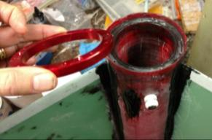

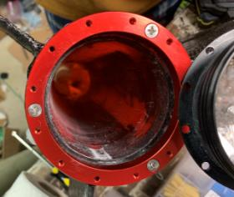

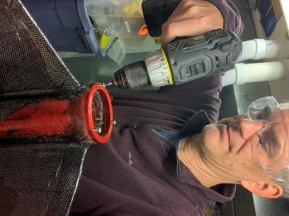

## Glass the fins

Glass the fins to the body tube to provide strength and maintain alignment.

Measure the carbon fiber cloth, peel ply, breather cloth, and sealant film.

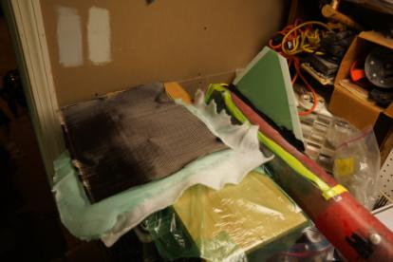

Lay up the stack.

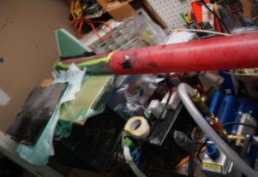

Apply resin (a similar fin shown here).

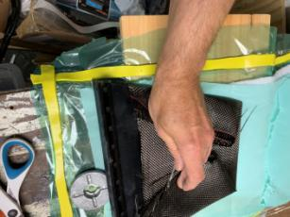

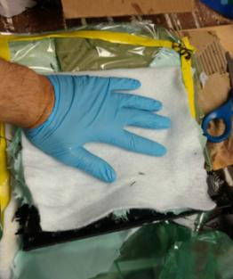

Mix the epoxy

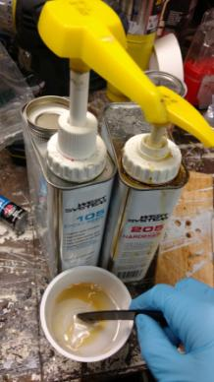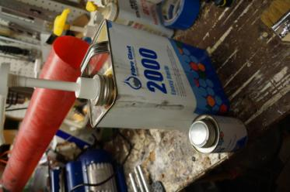

Pump it down and let it cure overnight

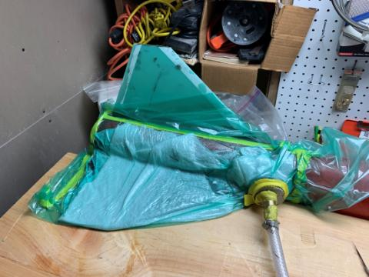

Voila!! A beautiful fin

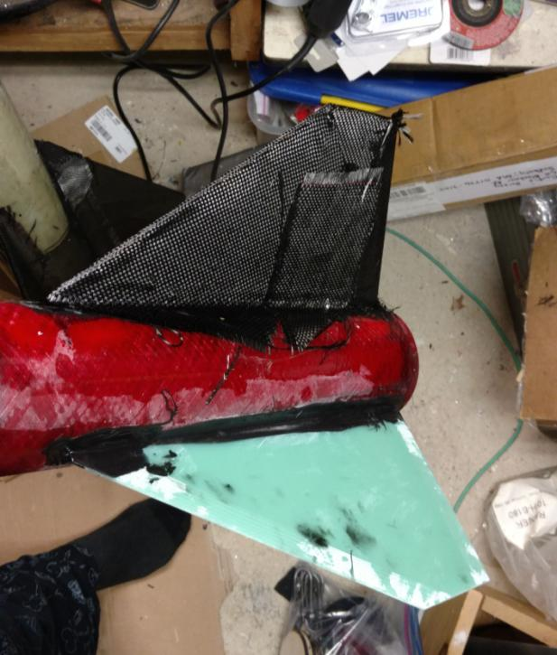  
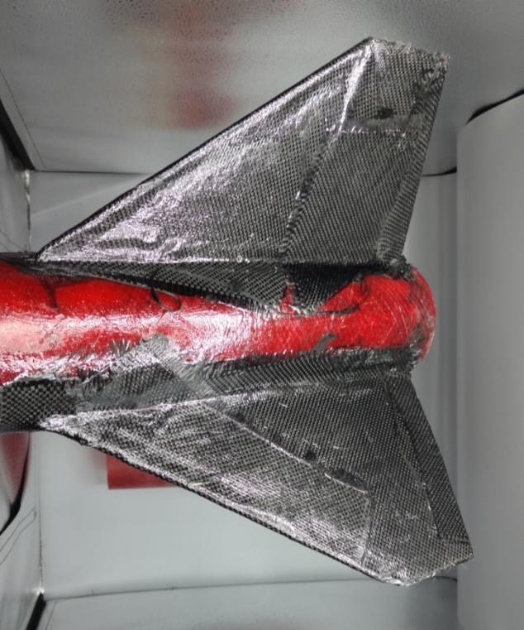

Tip-to-tip layer

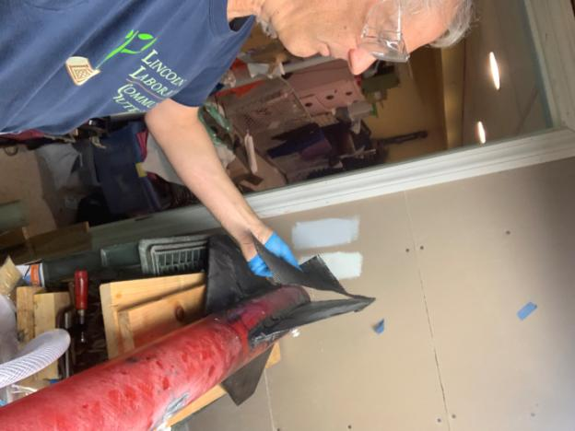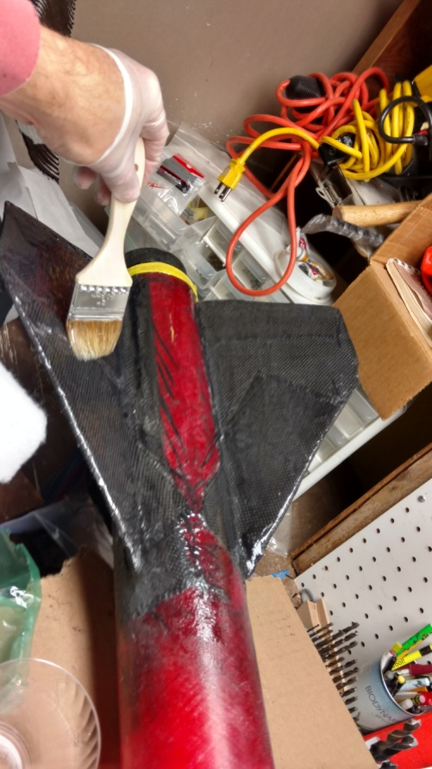

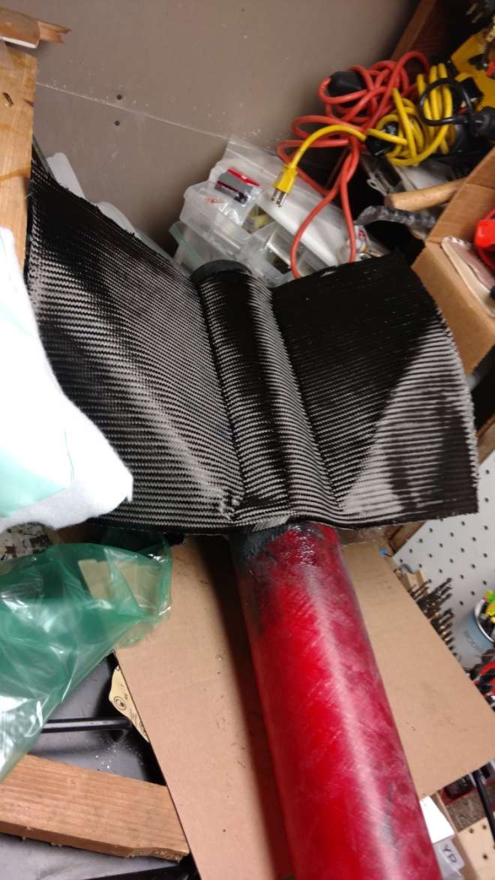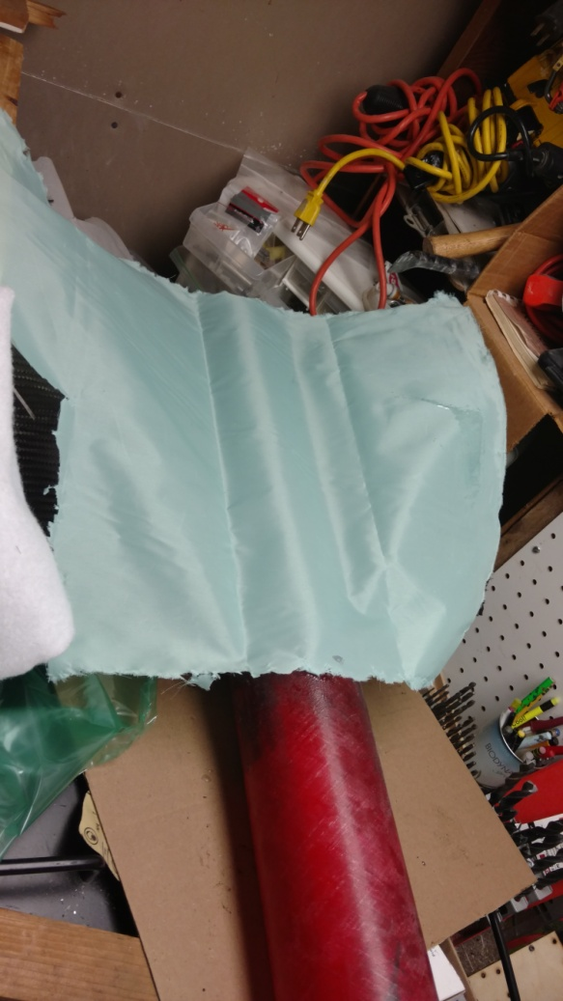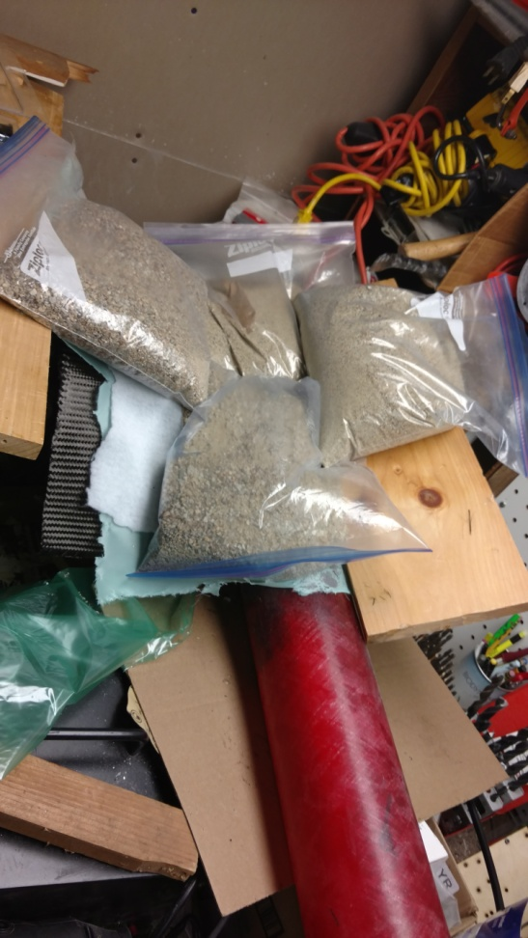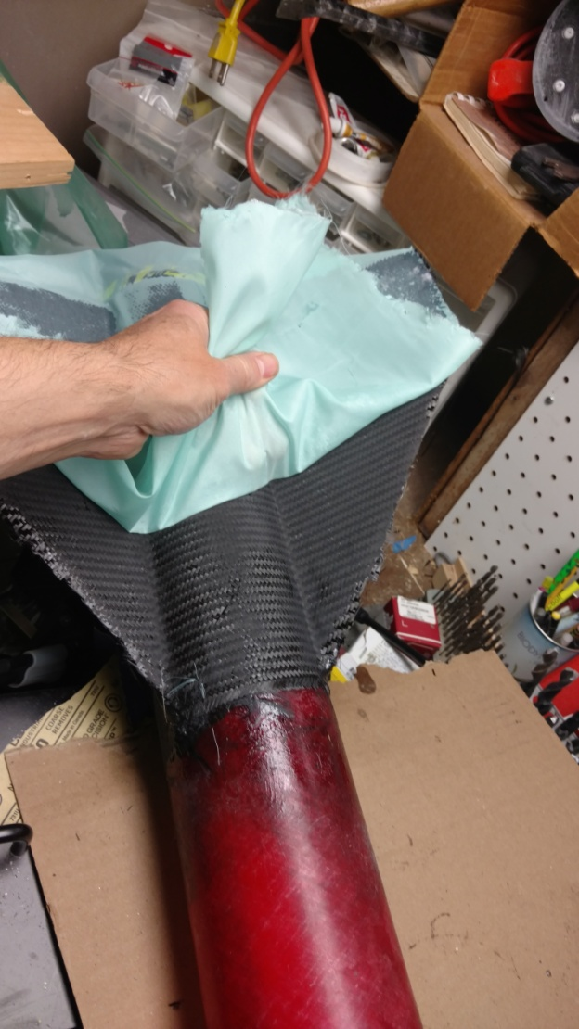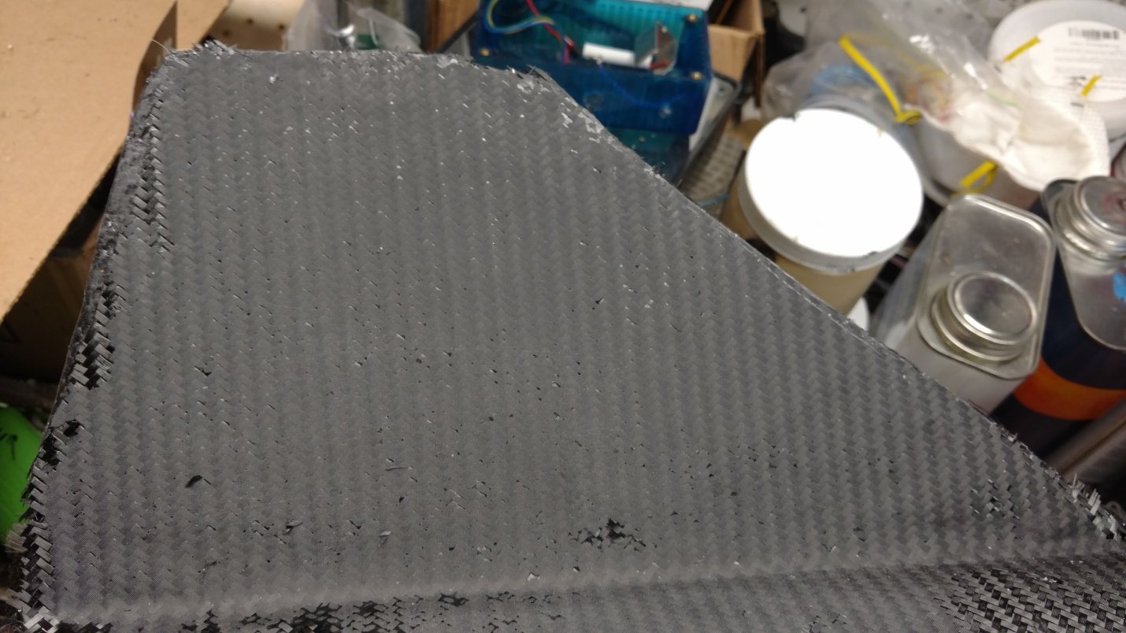

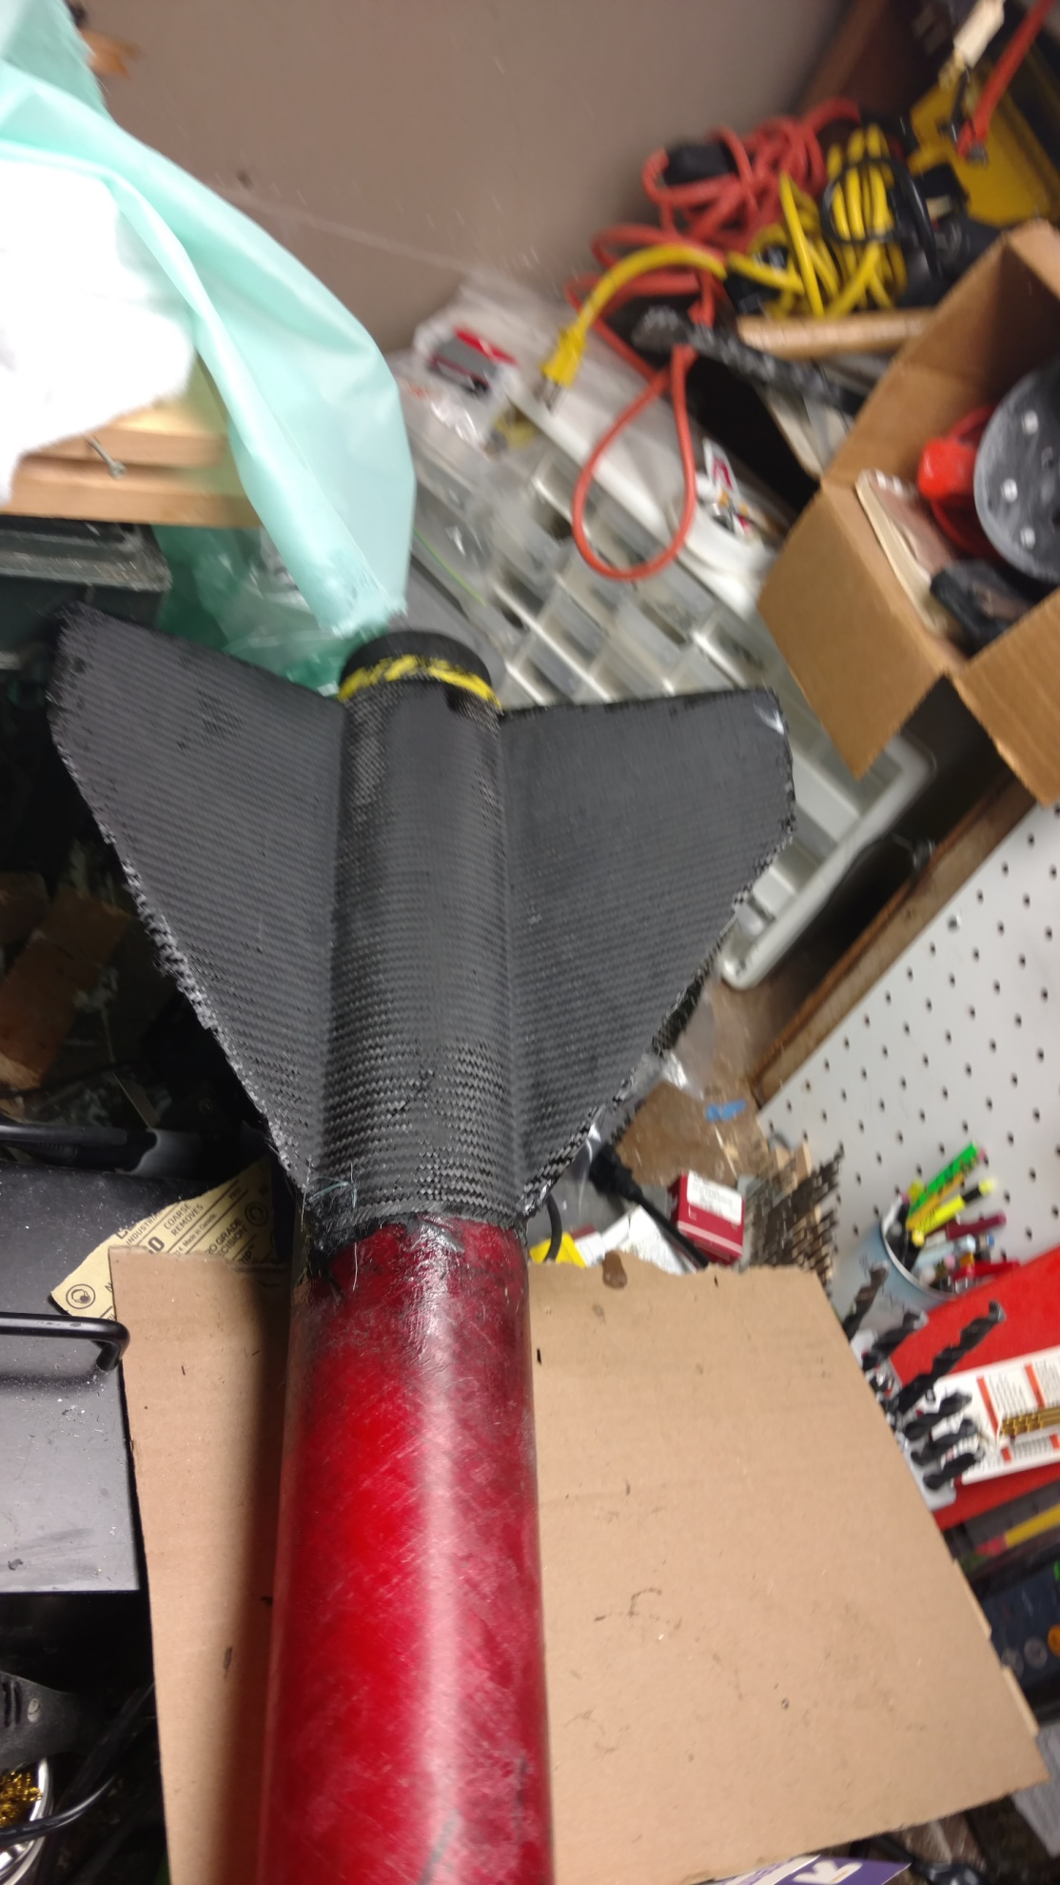

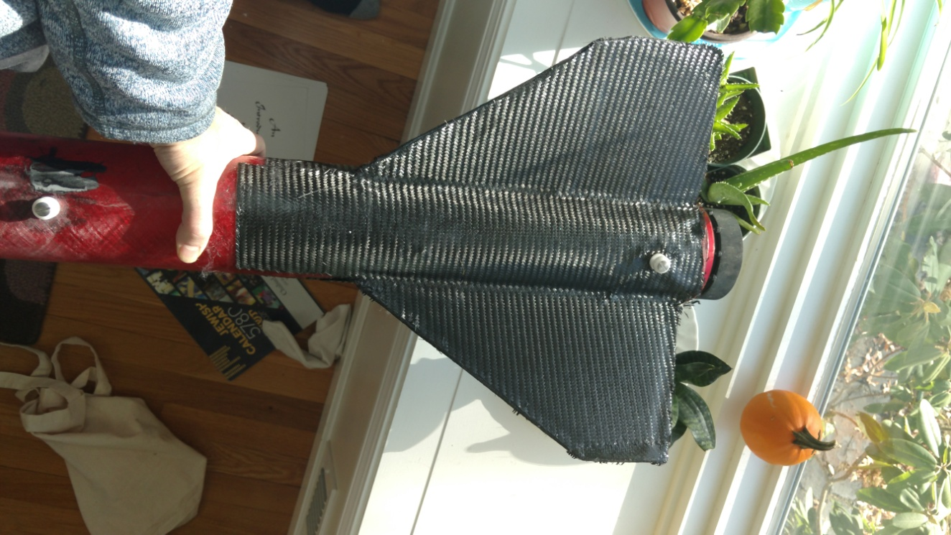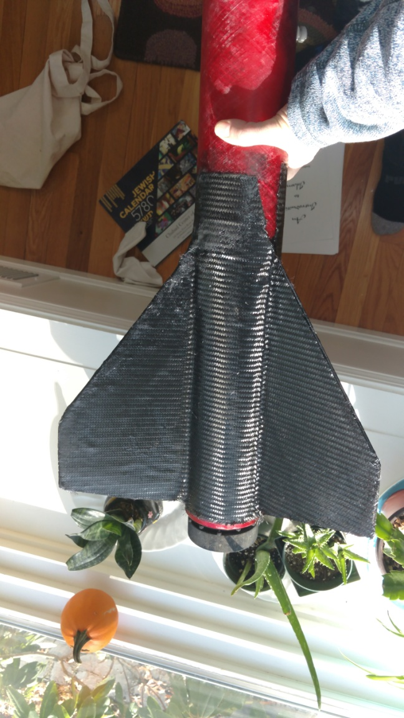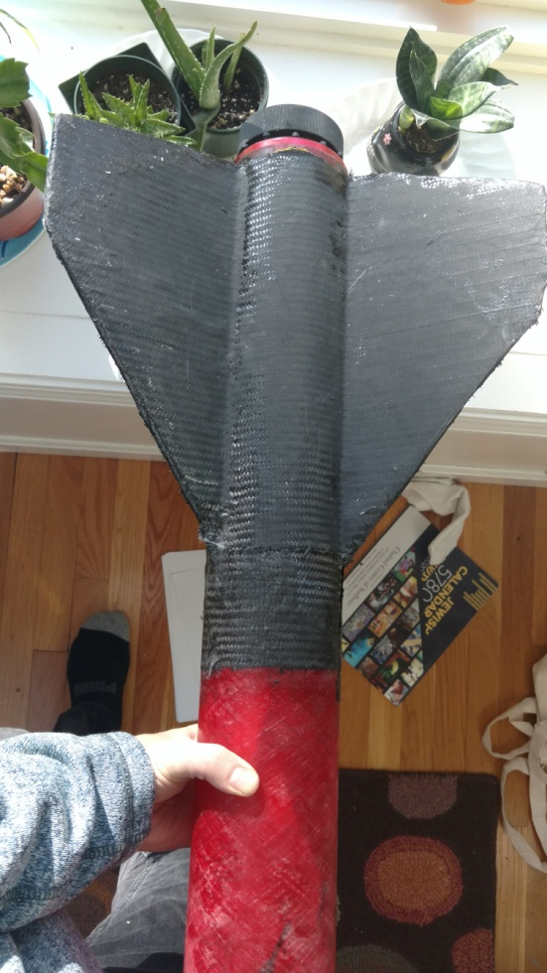

Treatment of edges

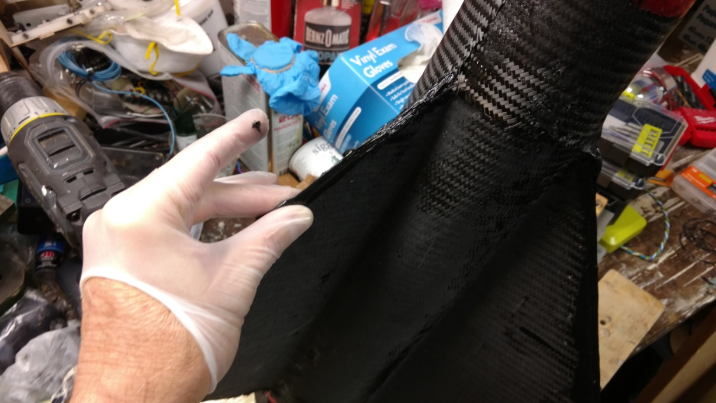

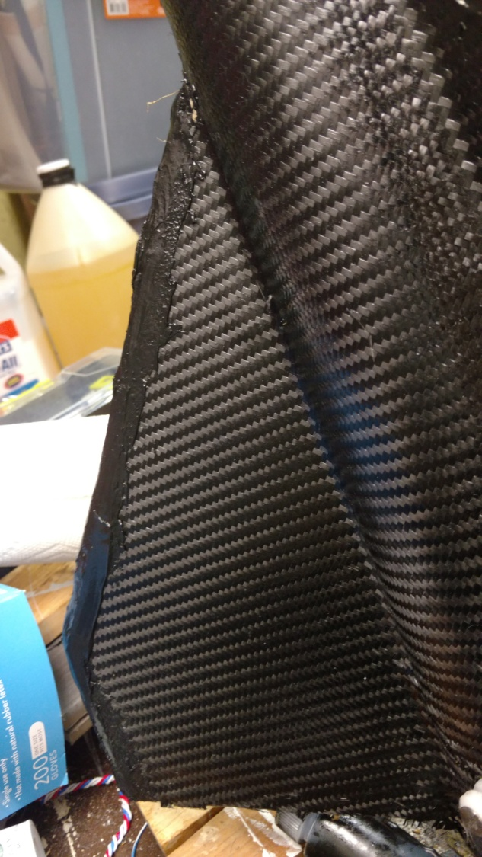

## Static Port sizing

## http://www.offwegorocketry.com/userfiles/file/Calculators/Static%20Port%20Holes.xls

## Av bay:

Altimeter holes

Offset static port holes from NC bolts (so turbulence doesn’t mess up altimeter) Create CAD drill template

Use #36 Drill (.1065) for 4-40 Nylon bolts so they press fit in snugly without threading

Use 3/32 Drill to tap NC screws for 4-40

Use 11/64 for 3 vent holes in the altimeter switch band

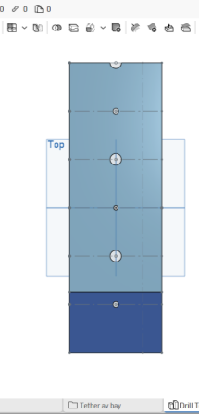

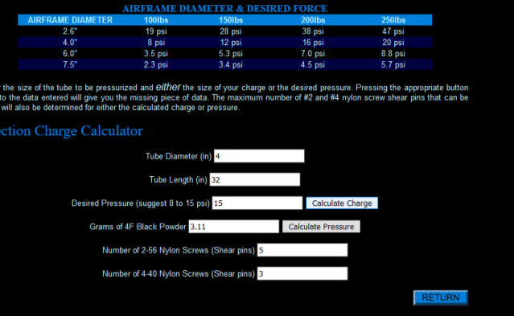

PSI gain

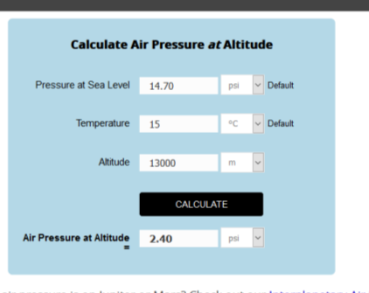

## Drilling Vent Holes

Measure the vent holes. Make sure vent holes and mounting nuts on NC do on align vertically

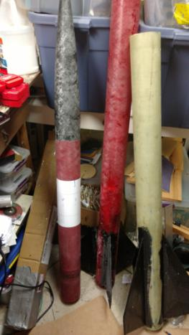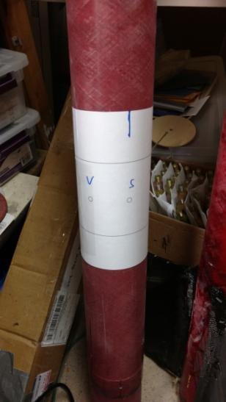

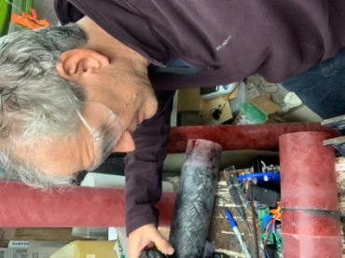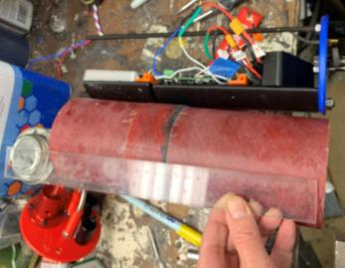

## Av bay Design

My CAD design for the altimeter bulkhead.

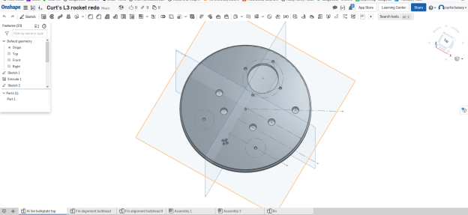

Altimeter bay hardware

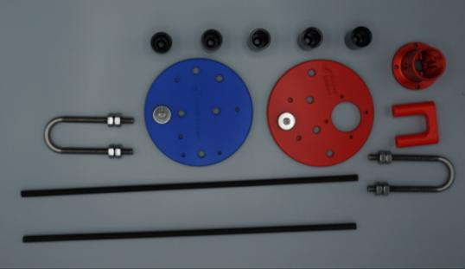

Assembled Bulkheads

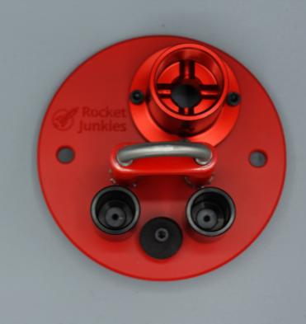

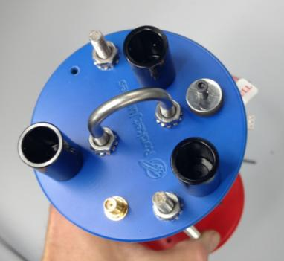

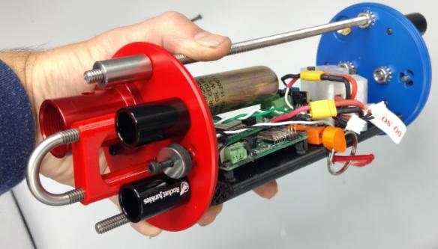

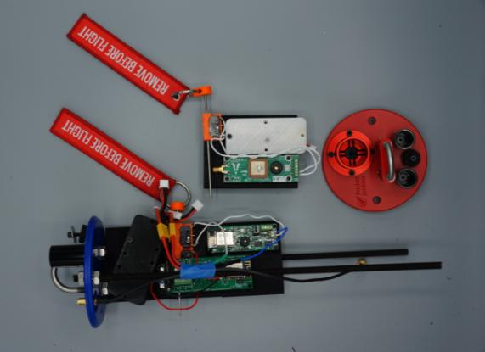

### NC Tracker

Tether av bay

Custom 3d printed of my own design

**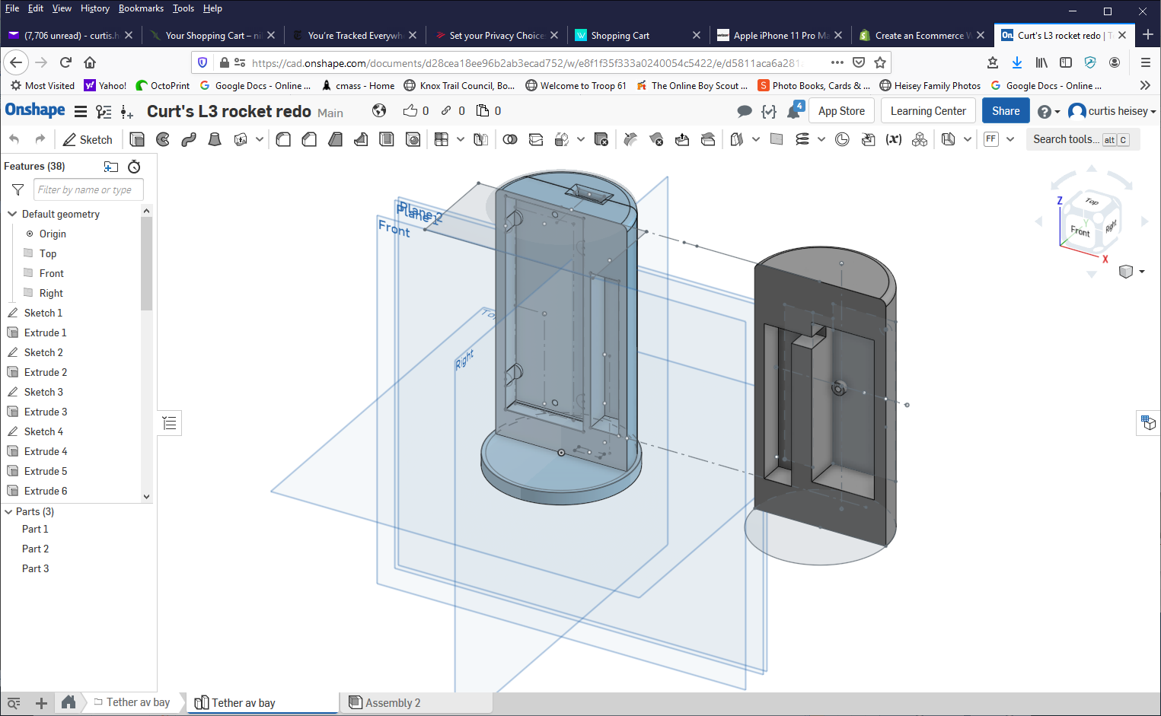**

**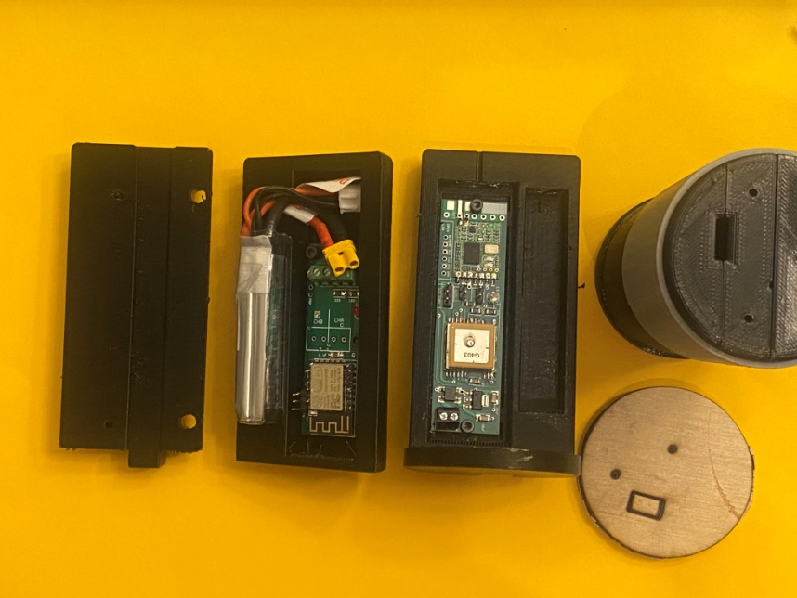**

## Altimeter Layout and Channel programming

Top view of the altimeter bay

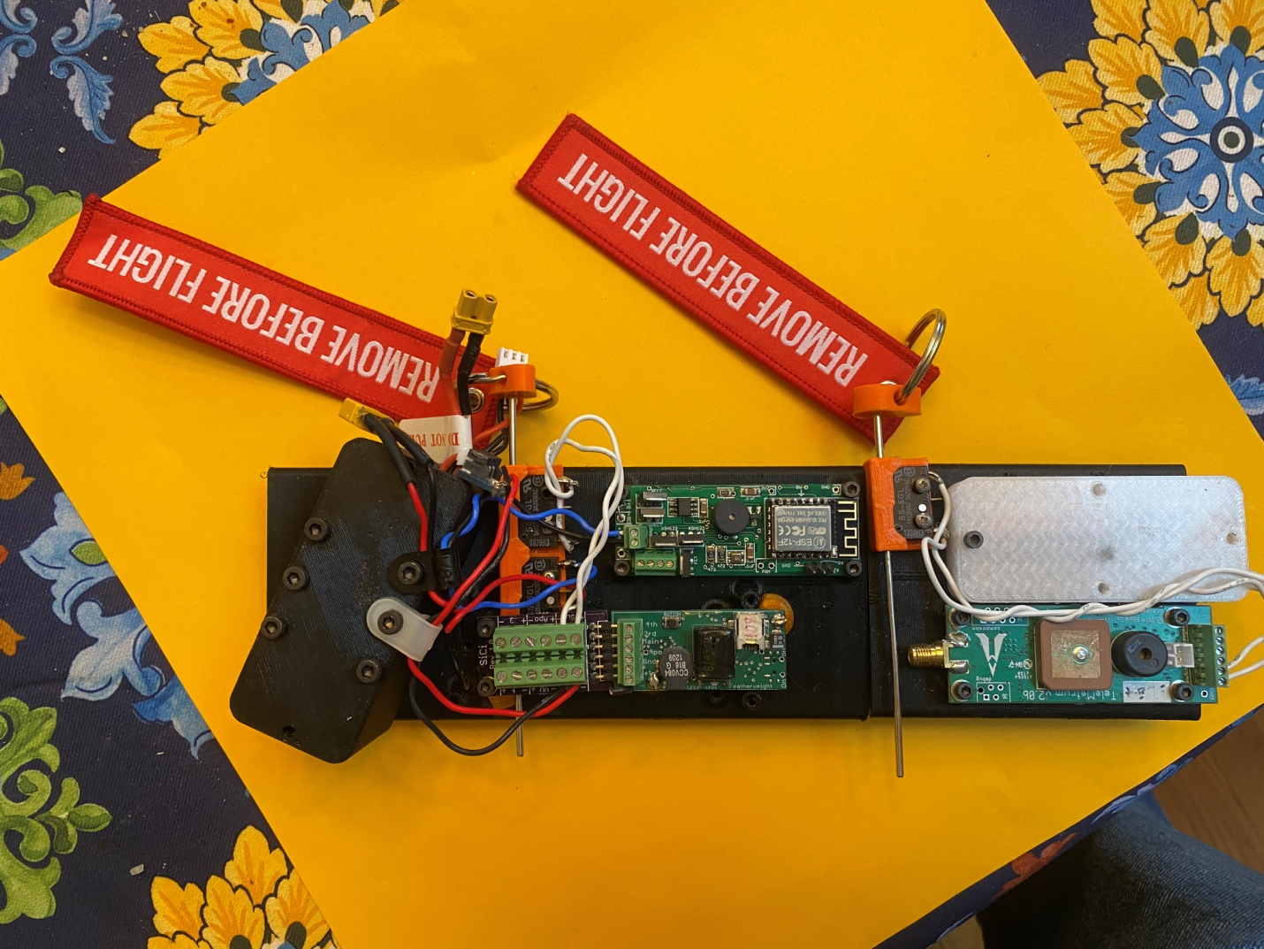

3

1

2

4

5

6

7

Eggtimer Quantum (1)

Raven (2)

TeleMetrum (3)

Batteries (two) for Eggtimerand Raven altimeters (4)

Battery for TeleMetruim (5)

Pull switches (two) for Eggtimer and Raven (6)

Pull Switch for TeleMetrium (7)

Screw terminal are positioned toward their respective assignments (e.g, main connections are located on the right)

All the altimeters can be turned on off from their battery connections via LabRat pull switches. In addition, the Eggtimer altimeters require wi-fi remote arming. The TeleMetruim has a data link to an antenna dongle.

## Altimeter Programming

Apogee:

BP charge with 2 BP backups

Main:

Tinder CO2 with 2 BP backups

|  |  |  |
| --- | --- | --- |
| **Altimeter** | **Output** Channel | **Function** |
| Eggtimer quantum,   |  |  | | --- | --- | | Quantum\_18A11 | 0463 8077 | | D- Apogee+1s |  |
| M- Main 700 CO2 Ignitor #1 |  |
| Raven | 1 Apogee |  |
| 2 Main 672 CO2 Ignitor #2 |  |
| 3 Apogee + 2s |  |
| 4 Main 480 |  |
| Telemetrum | D – Apogee + 3s  M – Main 600 |  |
| Eggtimer RF in NC | N/A | Telemetry only |
|  |  |  |

Tracker: AltusMetrum, Eggtimer RF in NC

BP: 3grams with 3 4-40 shear pins

<http://www.rimworld.com/nassarocketry/tools/chargecalc/index.html>

Lab Rat Pull switches

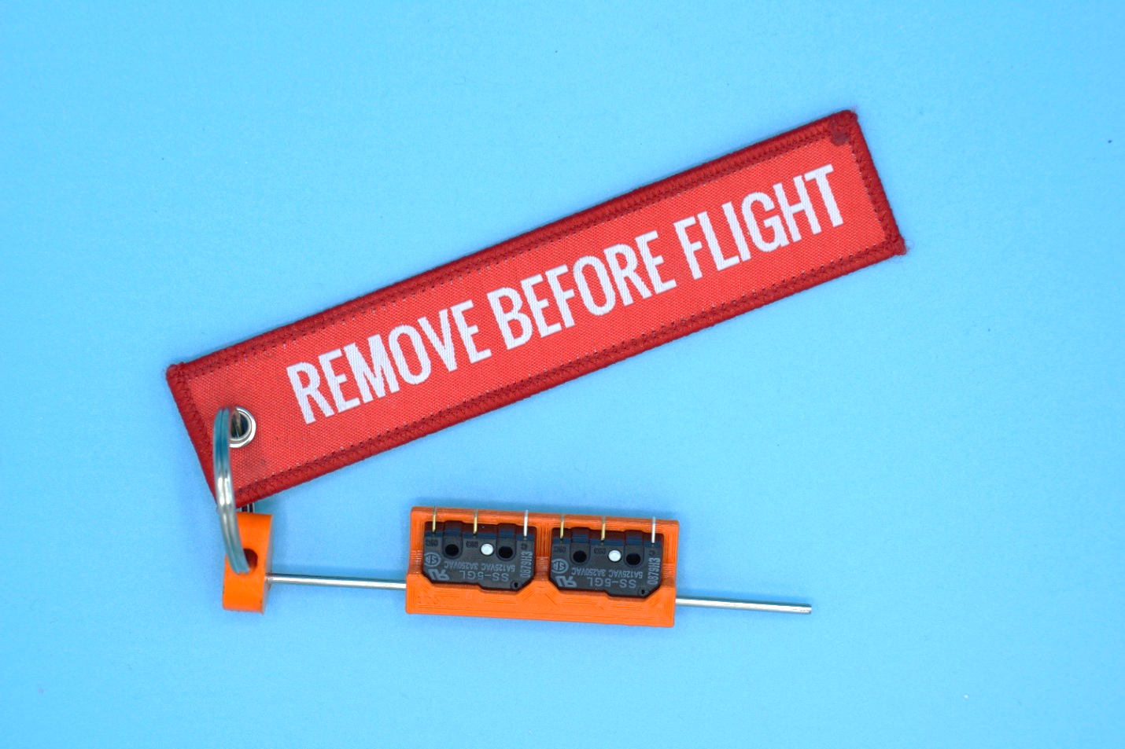

Telemetrum battery is 1S LiPo 600 mAh

600mAh 1S LiPo Battery 3.7V 50C JST-PH 2.0 PowerWhoop mCPX Connector for Inductrix FPV Plus Tiny 7 RC Micro FPV Quadcopter Drone

<https://www.amazon.com/gp/product/B077PRY7K3/ref=ppx_yo_dt_b_search_asin_title?ie=UTF8&psc=1>

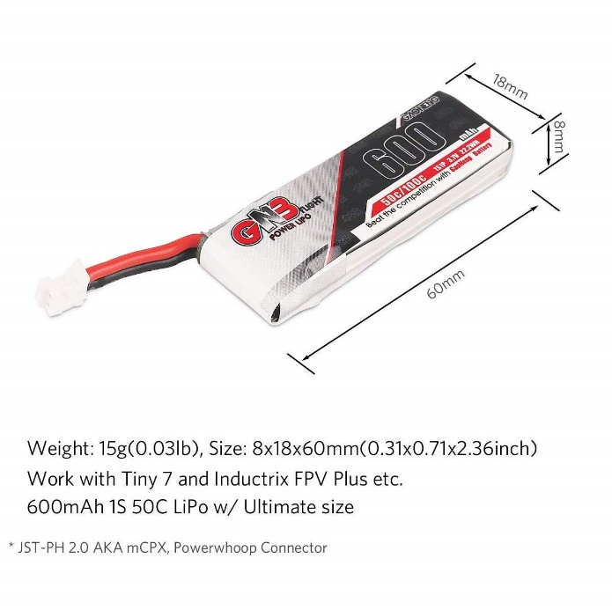

Eggtimer batteries are 2S LiPo 450 mAh

Tattu 4 Packs 450mAh 7.4V 75C 2S LiPo Battery Pack with XT30 Plug - Long Size for H Frame and BETAFPV 2S Whoop

https://www.amazon.com/gp/product/B07K18DJG5/ref=ppx\_yo\_dt\_b\_search\_asin\_title?ie=UTF8&psc=1

**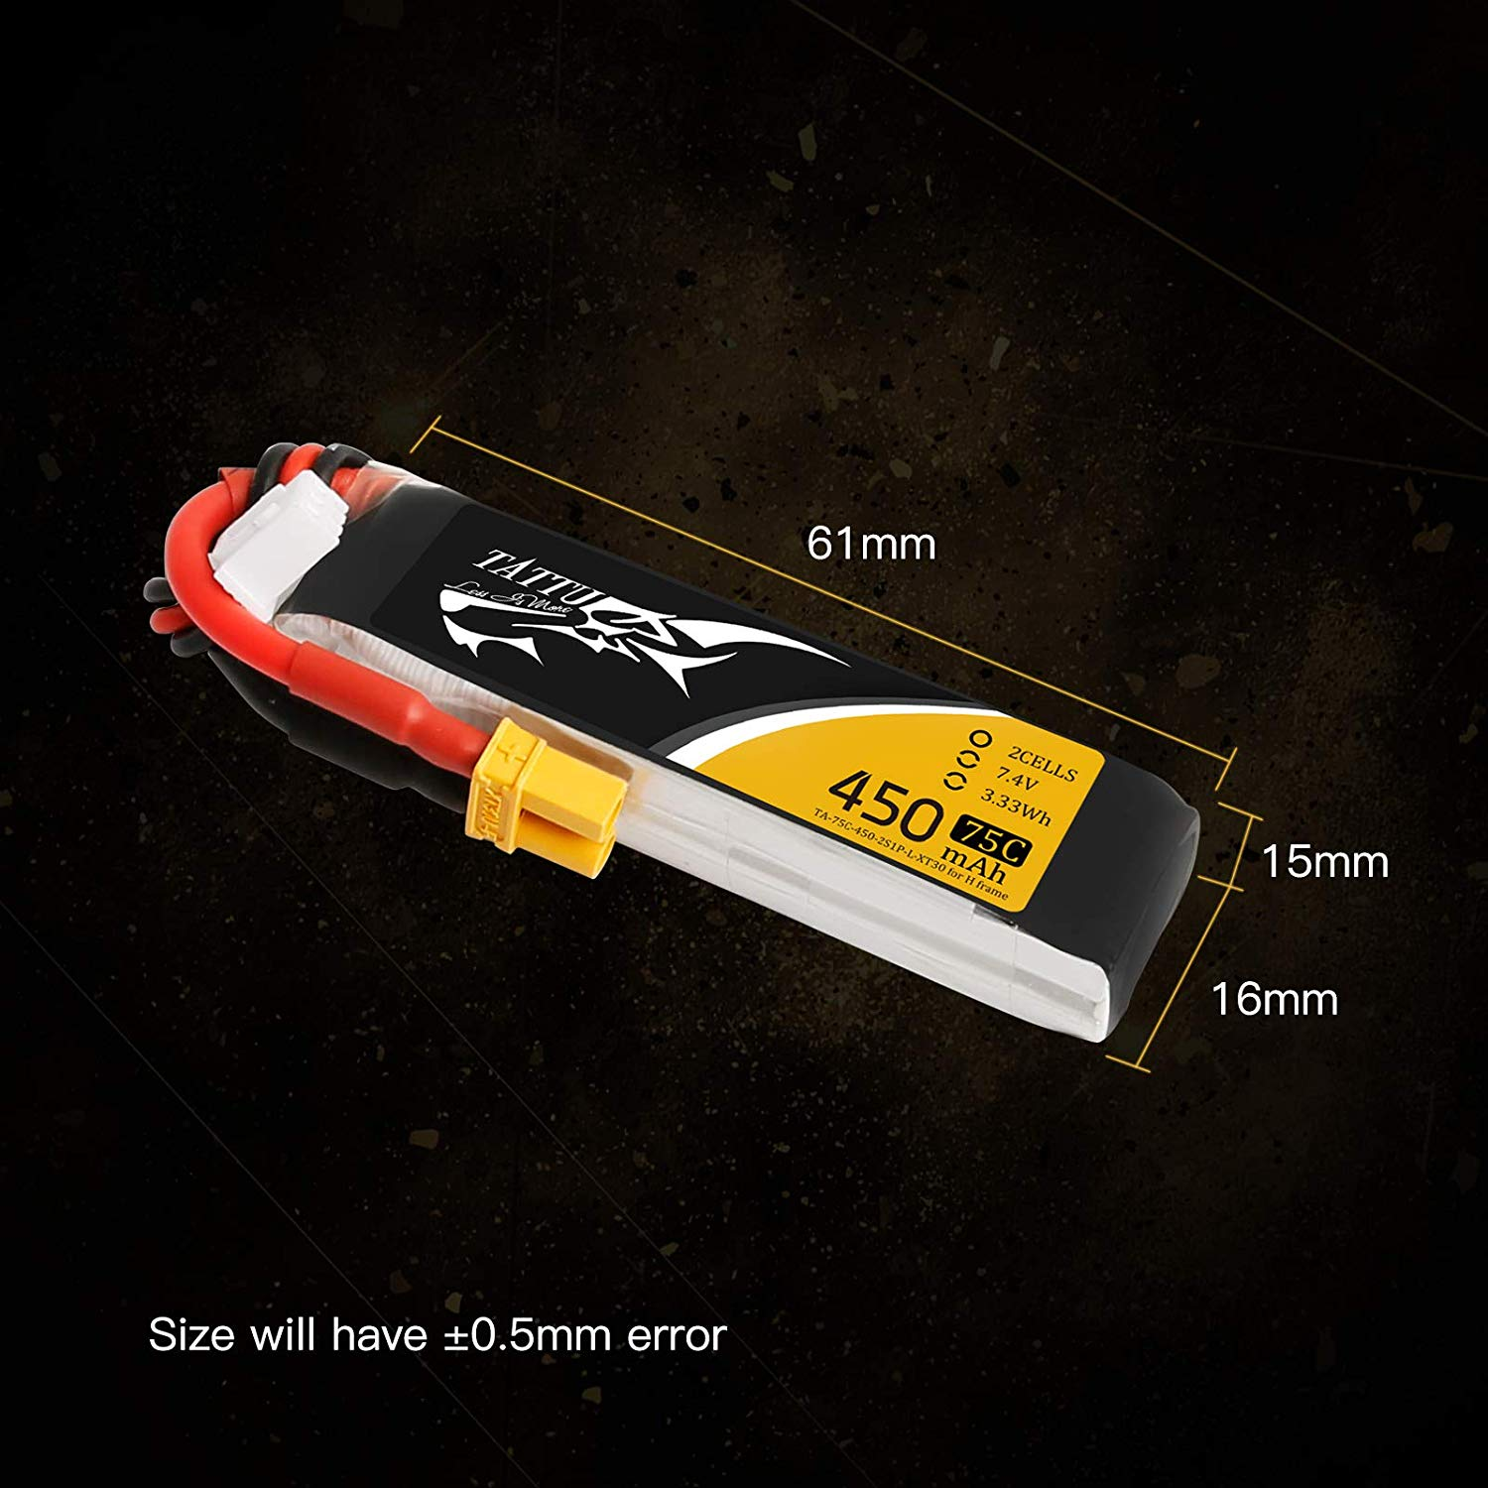**

### Telemetrum Channel Connections

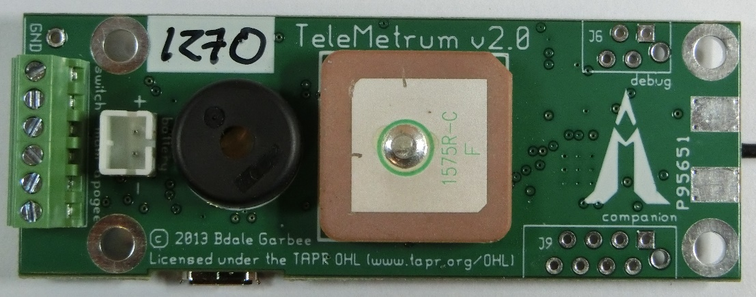



### Eggtimer Quanum Channel Connections

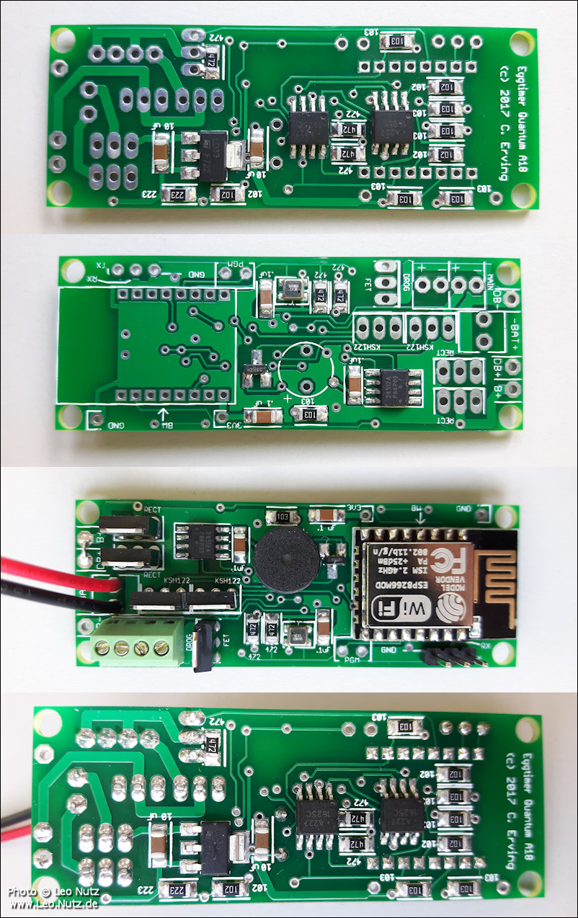

In the picture, Drogue channel is on left, main is on right

### Raven Connections

|  |  |  |
| --- | --- | --- |
| Raven | 1 Apogee |  |
| 2 Main 672 CO2 Ignitor #2 |  |
| 3 Apogee + 2s |  |
| 4 Main 480 |  |

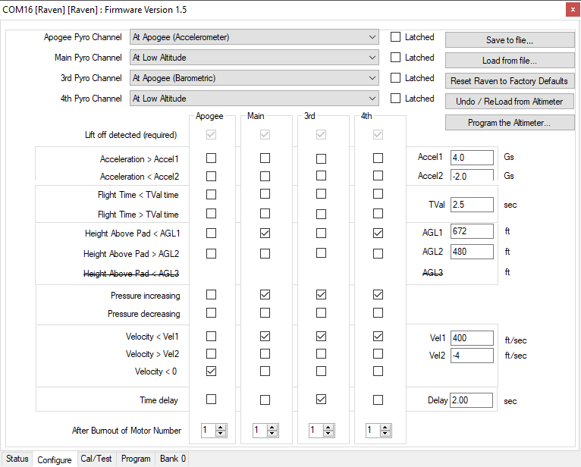

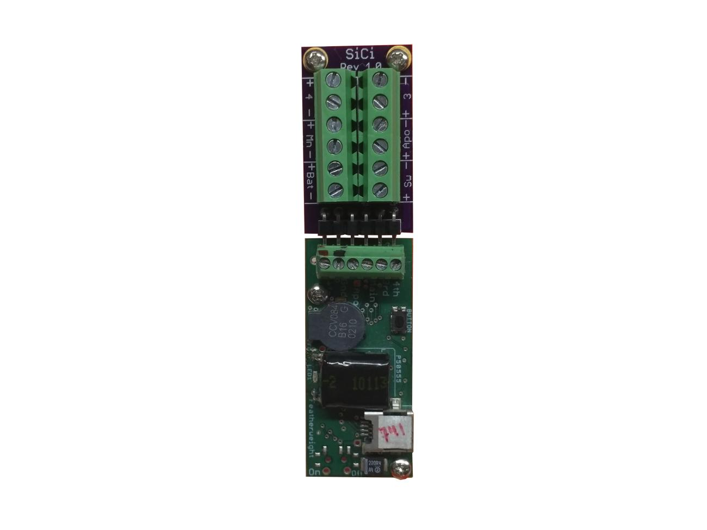

Igniters

MJG Firewire

Use sharpies to color code the ends.

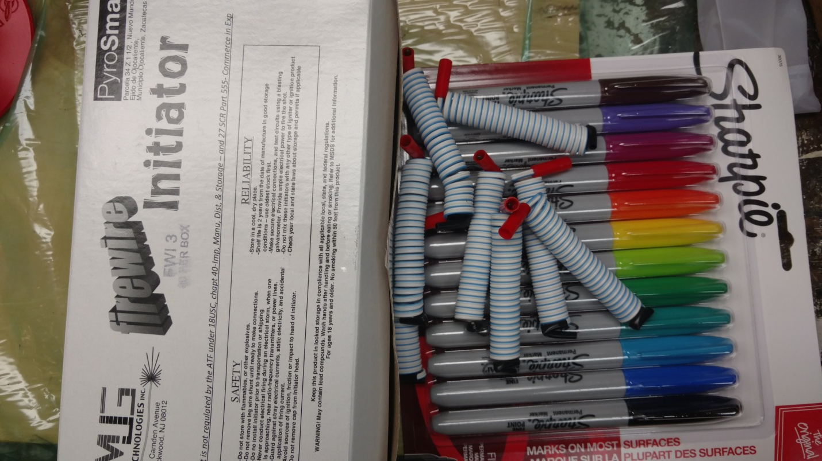

Tinder CO2 Raptor

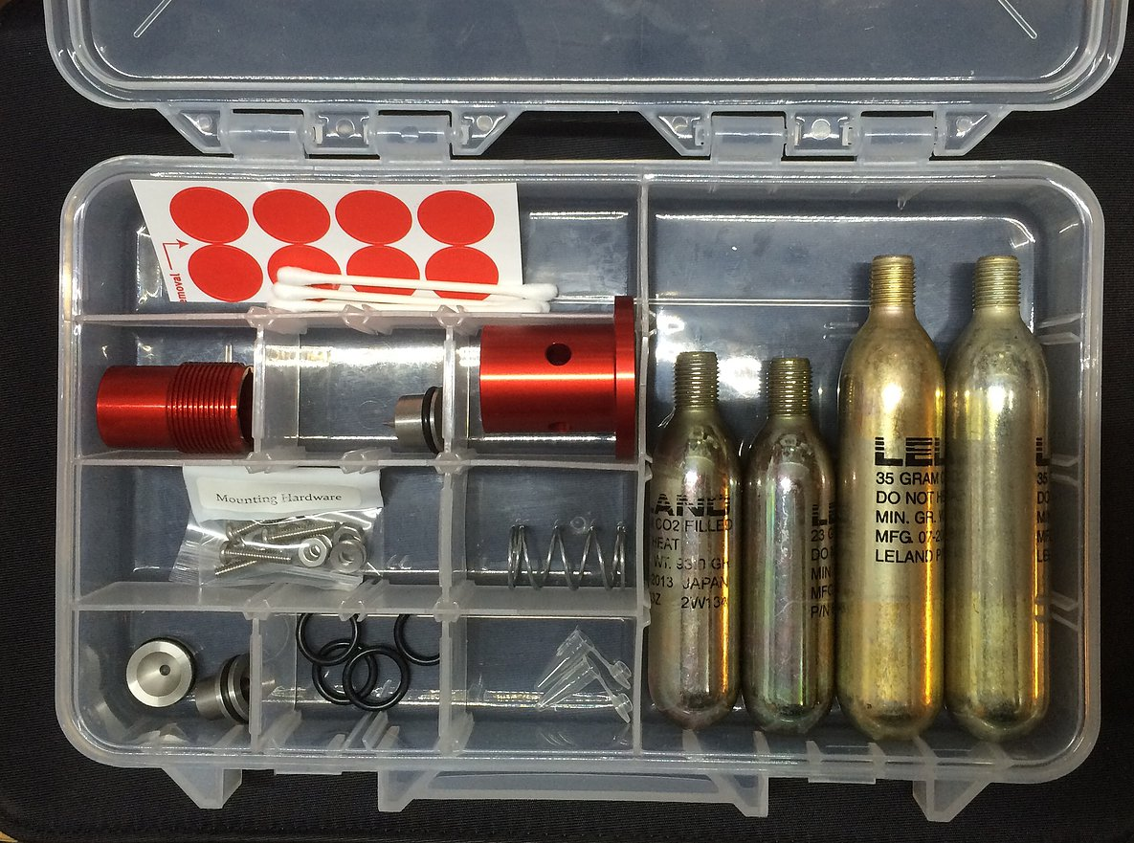

## Recovery:

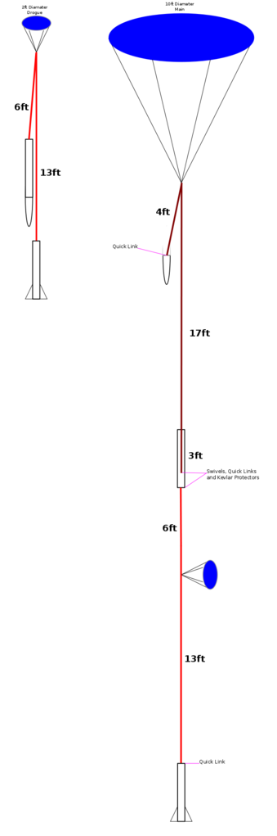

Note: Drogue attaches to Av bay

Bulk plate

**2 ft drogue**

**8 ft main**

**22 inches**

**0 ft**

**30 ft**

**22 ft**

**3 ft**

**0ft**

**22 ft**

**Drogue:**

24 inch Top Flight Ultra-X extra heavy duty lines https://topflightrecoveryllc.homestead.com/page1.html

**Main**

Empty rocket is ~ 20 lbs, so that should give 20 ft/s on8 ft main.

**Pilot:**

20% of main = 1.6 ft

|  |  |
| --- | --- |
| **Parachute** | **Description** |
| **Drogue** | **2ft w/reinforce lines**  **~ 70 ft/sec** |
| **Main** | **8Ft. Standard Parachute - Rocketman**  Weight of parachute: 10oz    Package Volume: 4.0”D x 6.5L”= 81.68”^3    Descent Rate: 15ft/sec: 12.0lbs 17ft/sec: 15.0lbs 20ft/sec: 20lbs 25ft/sec: 30lbs |

## Ready For Ground Testing

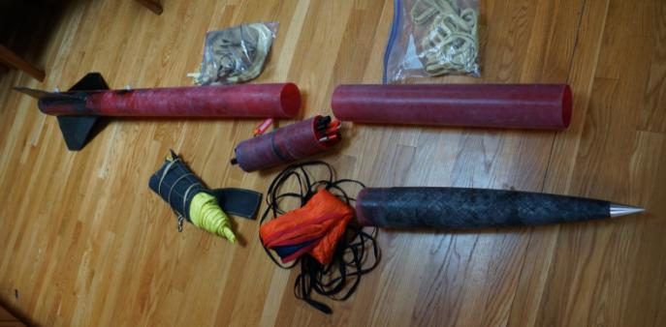

# Ground Testing

Main – CO2 ejection successful test 11/17/2019

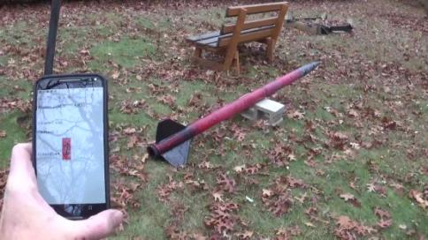

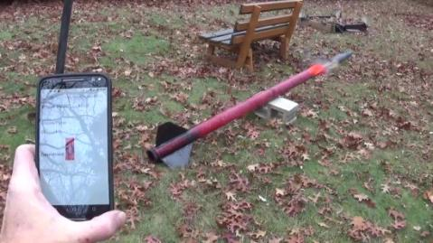

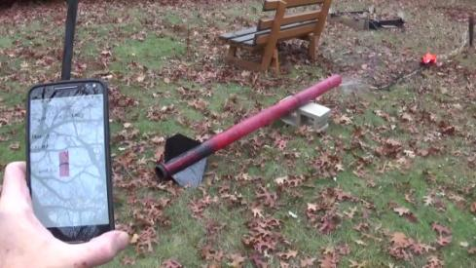

Drogue – BP ejection successful test 11/21/2019

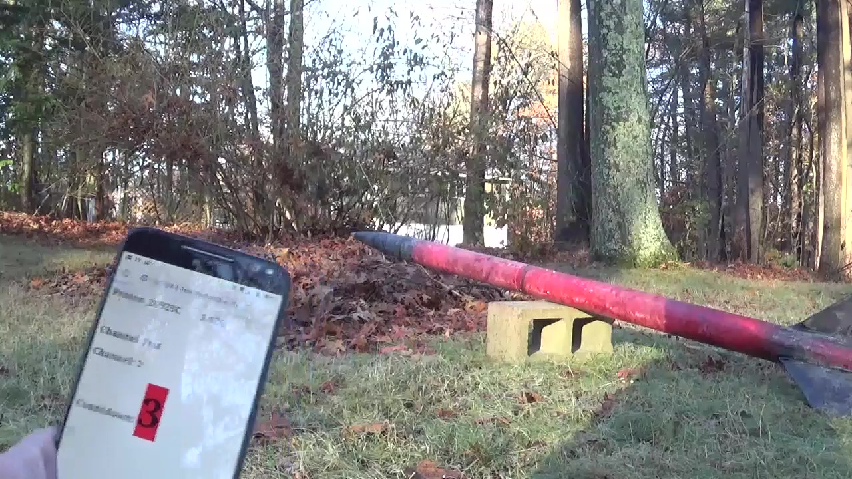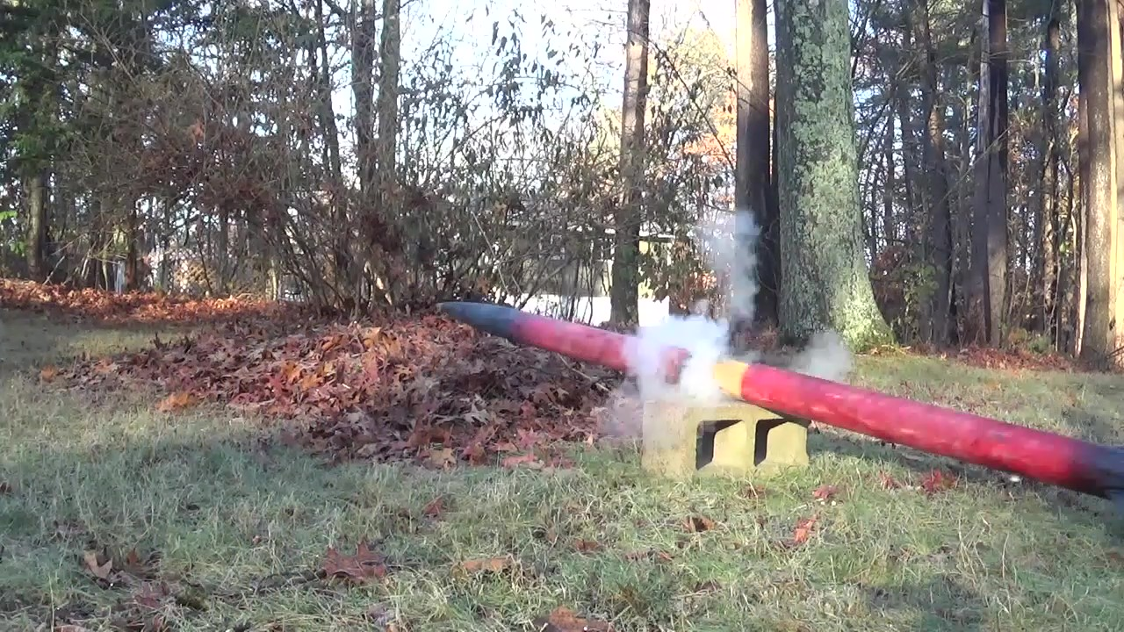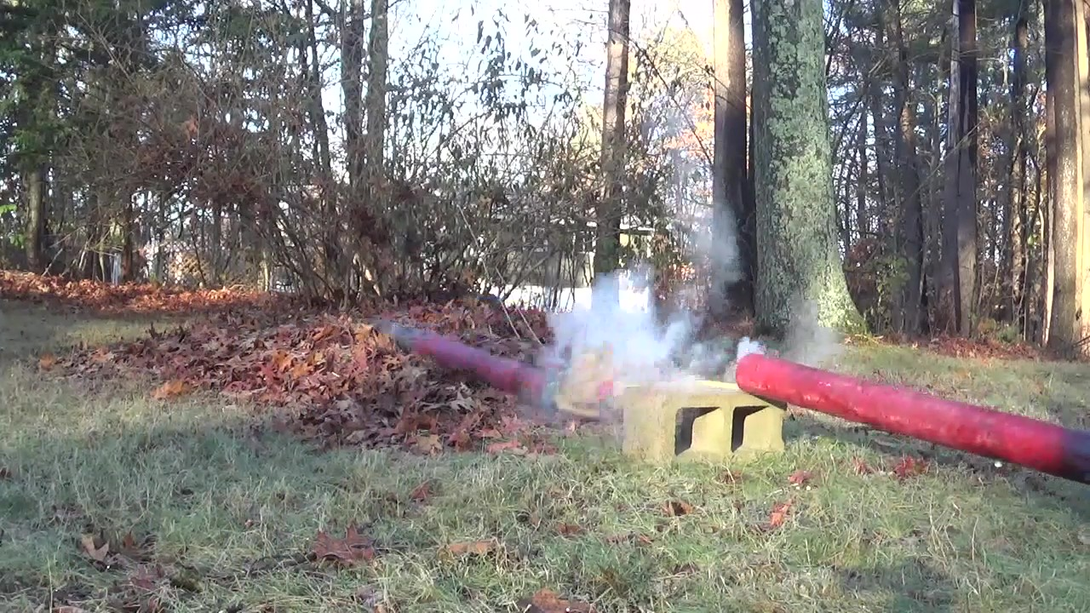

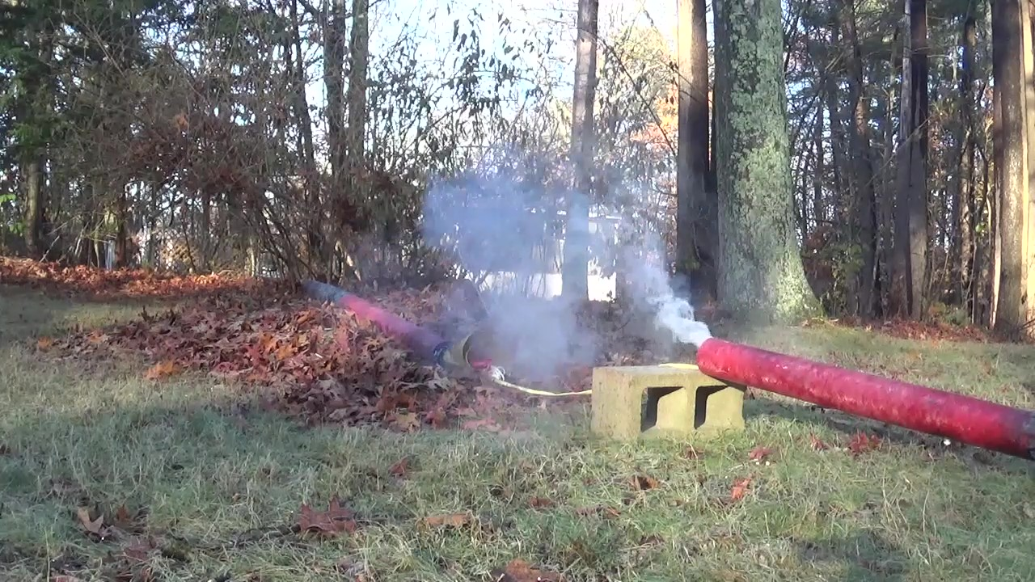

# Shakedown Flight on a “K”

CTI K454 54 mm w/ 76-54 Aeropac Adapter

Sims to 2500 feet

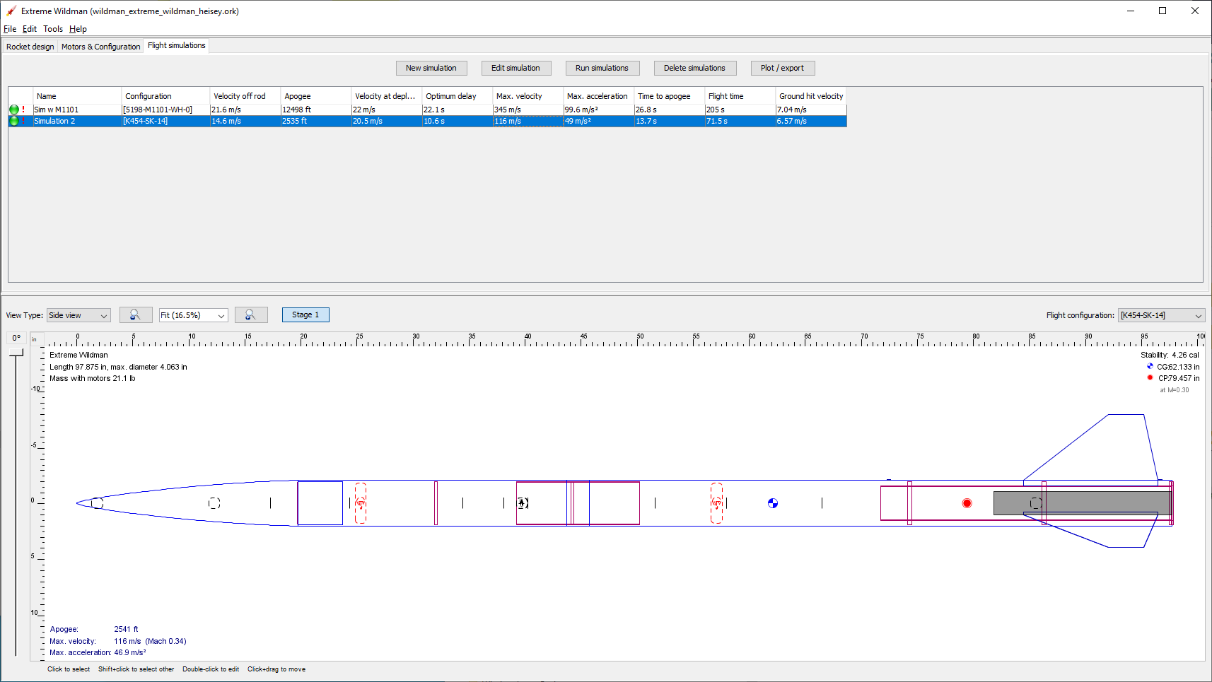

# Flight stability

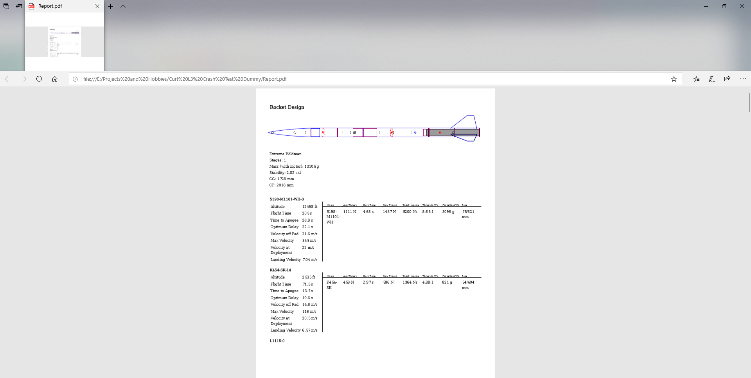

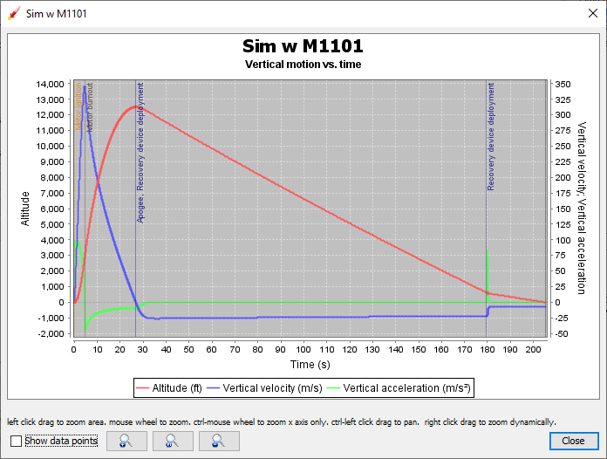

# Checklists

Full Checklist Forthcoming

Visual Checklist

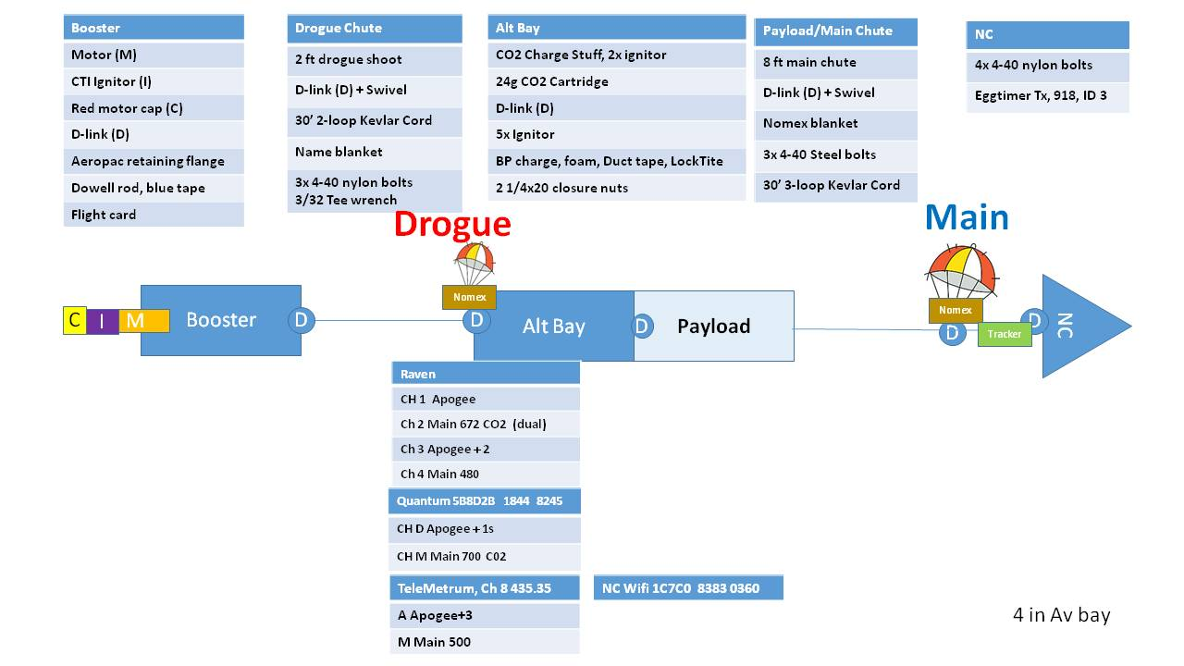

# Acknowledgements

I used Mark McCord’s L3 cert package as an outline <https://docs.google.com/document/d/1i4anunZXsiG7dyIP78nmFN7WJrSK-7uAgVvensHU9ok/edit>

And “dsigma”

https://github.com/dsigma/l3\_rocket\_certification/wiki

# Tripoli L3 Forms and Application

## Pre-Flight Data Capture Form

<http://www.tripoli.org/Portals/1/Documents/Certification/TAPPre-FlightDataCaptureForm.pdf>

## L3 Application

<http://www.tripoli.org/Portals/1/Documents/Certification/Universal_Certification_Form.pdf>

# Appendix- Parts to keep track of

### Push pin Core Pin (5/64 or 2mm)

### 0.074" Diameter, 2-1/2" Long

<https://www.mcmaster.com/98378a510>

### Female Threaded Round Standoff

### 18-8 Stainless Steel, 1/2" OD, 1" Long, 1/4"-20 Thread Size

<https://www.mcmaster.com/91125a412>

Drill bit for tight 4-40 clearance

### Black-Oxide High-Speed Steel Drill Bit

### Wire Gauge 36, 2-1/2" Overall Length

<https://www.mcmaster.com/2901a21>

### Stainless Steel Low-Profile Binding Barrels and Screws

### 8-32 Thread Size, for 1/2"-3/4" Material Thickness

https://www.mcmaster.com/94887a142

### Press-Fit Threaded Standoffs

### with Open End, 18-8 Stainless Steel 0.165" OD, 5/8" Long

|  |  |
| --- | --- |
| Thread Size | 4-40 |

<https://www.mcmaster.com/93090a651>

### Nylon Socket Head Screws

### 4-40 Thread Size, 1/4" Long

<https://www.mcmaster.com/95868a256>

Pixel Shutter Remote Control TW-283 Series 3.5mm Off Camera Shutter Connecting Cable Cord 3.5mm-S1 Camera Connecting Plug for Sony Cameras

https://www.amazon.com/gp/product/B07GWJHZ46/ref=ppx\_yo\_dt\_b\_asin\_title\_o08\_s00?ie=UTF8&psc=1

# Appendix- Av Bay BOM

# Appendix – Weight Budget

|  |  |  |  |
| --- | --- | --- | --- |
| Item | Weight |  |  |
| NC | 1506 |  |  |
| Payload | 0 | w NC |  |
| NC Tracker | 200 | est |  |
| Main | 387 |  |  |
| Bag | 50 | est |  |
| Cord | 540 |  |  |
| D-rings | 200 | est |  |
| Av bay w/CO2 and batteries | 1159 |  |  |
| Drogue | 409 |  |  |
| Av bay lid | 238 |  |  |
| Booster | 2970 | est |  |
| D-rings |  |  |  |
| Nomex |  |  |  |
| Cord | 181 |  |  |
| aeropac | 107 |  |  |
| thrust plate | 107 |  |  |
|  |  |  |  |
|  |  |  |  |
|  |  |  |  |
|  |  |  |  |
|  | 8054 | grams | 17.74009 |
|  |  |  |  |

# Appendix – Eggtimer Assembly

